**Costco’s Data Governance Strategy**

To make data governance rules we might first have answer to these questions:

* What does the term “Customer” means?
* How is the “Customer” represented?
* In what system are data elements on “Customer” recorded?

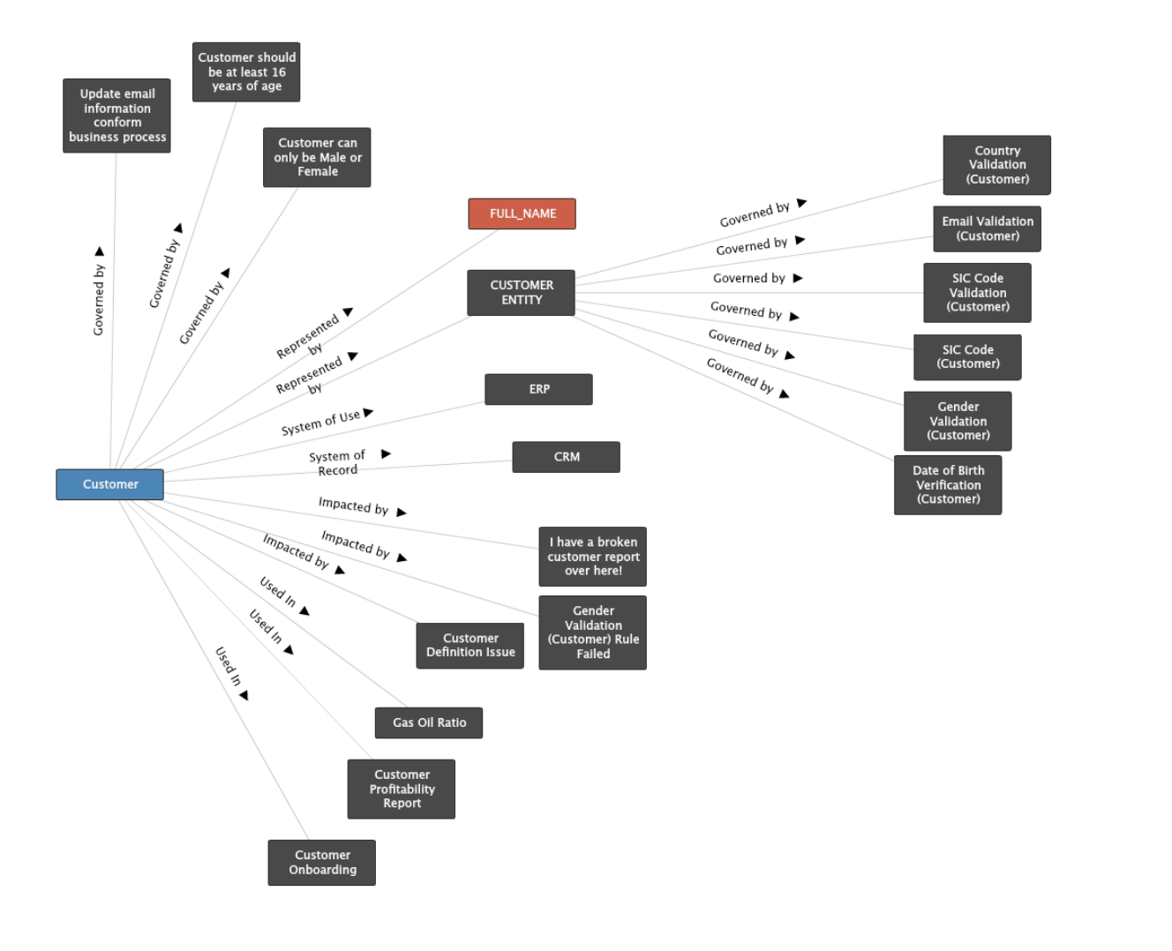

This is the Detailed explanation of a Customer:

- By what Data governance rules or policies it follows/govern by.

- What “FULL_NAME” represents.

- In which system is it used?

- In which system is the data of this customer being recorded?

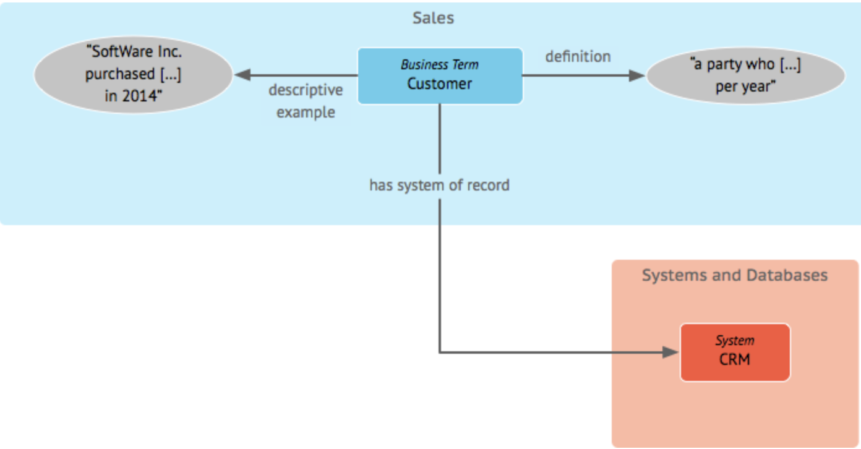

**Business Term (“Customer”)**: Represents a key term in the Costco data environment. A clear definition is provided for consistency. For example, “Customer” may be defined as “a person who has an active membership or made a purchase in the last year.”

**Descriptive Example**: Includes an actual example, like “John Doe, who purchased items in 2023,” to make the term relatable and ensure everyone understands what constitutes a customer.

Master Data Management (MDM): Centralize data in an MDM system to create a single source of truth for products, suppliers, and customers, reducing data silos.

**System of Record (CRM System)**: Indicates where the information about customers is stored and managed. At Costco, customer data could be stored in a **CRM system** that acts as the central place for managing all customer-related records, such as membership information, purchase history, and contact details.

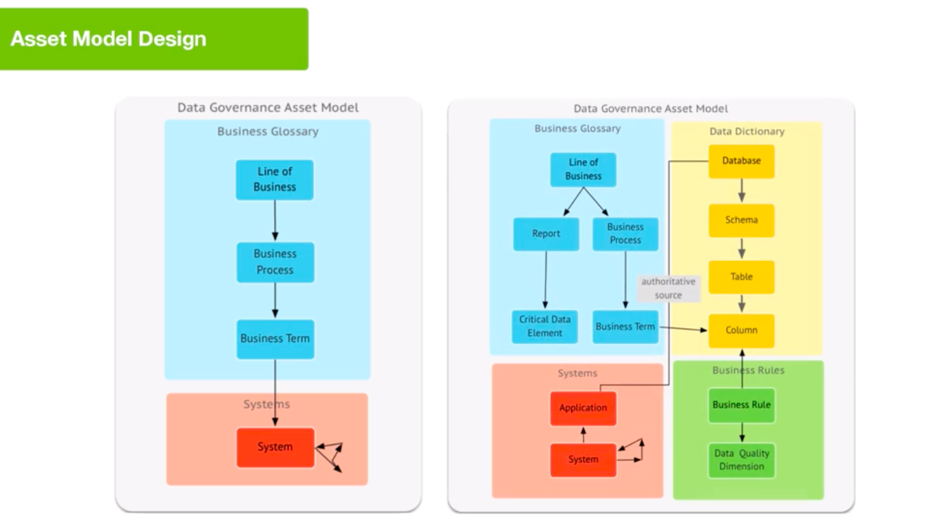

For the Costco ERD and database schema provided, we can establish data governance policies to ensure data integrity, quality, security, and proper management of data assets. Here’s an out-of-the-box data governance mechanism tailored to this specific ERD:

**Data Governance Asset Model for Costco and can be applied for many other Data Warehouse Tables and Columns.**

|  | **Distribution Center, Warehouse, and Product Data - Owned by Logistics Data Steward** | **Customer, Membership, and Costco Card Data - Owned by Customer Data Steward** |
| --- | --- | --- |
| **Line of Business**: | The **Distribution Center**, **Warehouse**, and **Product** data fall under the **Supply Chain Management** line of business. | The **Customer**, **Membership**, and **Credit Card** data fall under the **Customer Relations** line of business. |
| **Business Process** | For these assets, the business processes might include **Inventory Management**, **Product Distribution**, and **Stock Replenishment**. These processes define the flow and interaction of data between the **Distribution Center**, **Warehouse**, and **Product** tables, capturing how products move across distribution centers and are managed at warehouses. | These assets are managed through **Membership Enrollment**, **Credit Card Management**, and **Customer Service** processes. |
| **Business Term** | Key business terms related to these assets include:  **Product ID** and **Warehouse ID**. | Terms like **Customer ID**, **Membership ID**, and **Credit Limit** are defined in the **Business Glossary**.  For example, **Customer ID** is defined as a unique identifier used to track each member throughout Costco’s services. |
| **System of Record** | This data is managed in **Logistics Systems**, which act as the system of record. For instance, inventory data is recorded and updated in a **Warehouse Management System (WMS)**, and logistics processes might use specific **Enterprise Resource Planning (ERP)** software. | The **CRM (Customer Relationship Management)** system acts as the **authoritative source** for customer data. The CRM maintains customer information like membership status, purchase history, and credit card usage. |
| **Data Dictionary** | For each of the entities like **Distribution Center**, **Warehouse**, and **Products**, a detailed **data dictionary** is maintained | The **Customer** and **Membership** data assets are defined in the data dictionary |
| **Business Rules** | Specific business rules are implemented to manage data quality. For example:**Product Stock Levels** must be updated whenever there is a restock.**Distribution Center Capacity** should not exceed a predefined limit. | **Validation rules** such as valid **Contact Email** format are enforced. **Membership Renewal Dates** are monitored to ensure timely renewals. |
| **Data Quality Dimension** | Metrics are established for monitoring; **Accuracy of Product Quantity** and **Completeness** of **Warehouse Address** information. | **Accuracy** of **Customer Contact Information** and **completeness** of **Credit Card Details** are continuously monitored. |